Analyse your Current Teaching Context

Refer to your Module Specification as it will provide you with the relevant information on the following:
Module Code:
Module Title:
Department:
Credits:

Student Workload – scheduled learning and teaching activities
- Lectures
- Seminars
- Tutorials
- Project supervision
- Demonstration
- Practical classes and workshops
- Supervised time in studio/workshop
- Fieldwork
- External Visits
- Work Based Learning
- Guided Independent Study
- Placement
- Year Abroad

Intended Learning Outcomes:

Teaching and Learning Methods:

Assessment Methods:

Identify the Educational Need or Problem

Nature of student cohort (UG, PGT, international students, professionals):

Students’ perceptions of the module:

Other perceptions: (e.g. peers, external examiners, professional groups, employers)

Other data about module impact: (e.g. student grades over time, number repeating, attrition rates, benchmarking of assessment grades)

Overall evaluation of quality of the module (strengths and weaknesses)

Nature of desired changes to the module

Propose Your Project Plan

Optimising learning through multiple modes | How can ‘multiple modes’ add value to your module or parts thereof? (f2f; online; synchronous; asynchronous)
 | Which aspects of your module require f2f contact and why?
 | What type of resources will support your proposed learning design?
 | Are there resources available (commercially produced or open source) to support your module design?
Proposed new study requirements | Total hours of f2f hours of participation on campus
 | Distribution of f2f hours (regular/irregular; lectures/tutorials/seminars/labs/ campus/work placement/fieldwork)
 | Total hours of non-f2f participation/ self-study
Project timeline

Evaluation plan

Additional resource needs or services | - Additional/changes to library resources
 | - Specialised IT hardware/software
 | - Changes to timetabling (e.g. changed teaching space needs from large to small rooms or vice versa, to IT labs or library space)
 | - Sourcing and integration of commercially published or open access learning materials
 | - Video filming (e.g. of short vignettes) and editing
 | - Audio or video recording of lectures (lecture capture)
 | - Webinar development (Adobe Connect)
 | - Training of teaching staff in use of Moodle; Echo 360; Turnitin; GradeMark; Mahara; Pebble Pad

Build your Blended Learning Design

A protocol has been developed to illustrate a learning design in a temporal format to provide a standard form of communication to describe different kinds of learning designs. The critical elements required in a learning design, particularly when ICT mediated (Oliver, 1999, 2001; Oliver & Herrington, 2001) are:
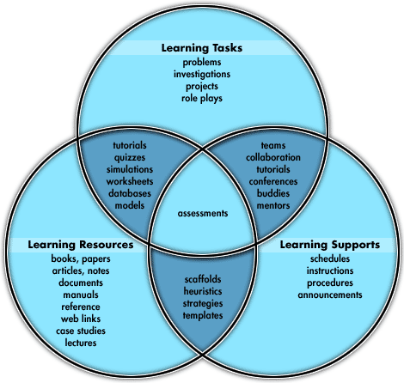

Learning Resources | Learning Tasks | Learning Supports
Intended Learning Outcomes:

Resources/Supports (under the appropriate licences) | Format
 | Text /Graphics (photos; cartoons; drawings) | Audio | Video | Slides (e.g. PowerPoint; Prezi) | Other (e.g. Adobe Presenter; Xerte; Camtasia)
I can reuse as is
I can tweak and use
I can repurpose and use
I can create for this module

Critique your Blended Learning Design

Does the learning design engage learners?
How does the design consider the learners’ prior knowledge and experiences?

Does the design acknowledge the learning context?
How does the design consider the broader programme of study for the learner?

Does the design challenge learners?
How does the design seek the active participation of learners?

How does the design encourage learners to be self-critical and supporting learners’ ampliative skills?

Does the design provide practice?
How does the design encourage learners to articulate and demonstrate to themselves and their peers what they are learning?

Evaluate Your Blended Learning Module
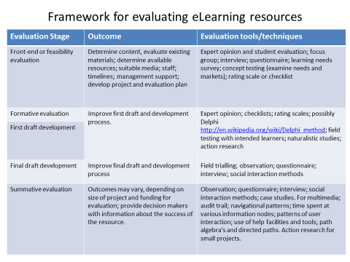
What is post-module evaluation?
A post-module evaluation is distributed to participants at the end of the module. This could be done in class or online. It has questions designed to help you gather information about how the learners felt about the module, and how much they felt they’d learnt. Post-module evaluations tend to measure participants opinions and their personal feelings about the module, and not the actual amount of learning that occurred. By administering a post-module evaluation, you will be able to glean an insight into what your participants liked and didn't like about your module and the online learning resources within it, and how satisfied they felt with the module. The data you collect through this evaluation, will help you to improve the blended learning experience you have developed for your module and apply what you have learnt to future blended learning designs.
What tools are available to create a post-module evaluation?
There are some well-known free (and some not free) survey tools available online, notably Survey Monkey and Google Docs. These applications allow you to easily create a survey and insert various question types, and then notifies you by e-mail (or some other way) when people respond to your survey. These survey tools also allow you to easily look at and gather the results of your survey. You could consider adding questions to your SET or SEM evaluations.

Blended Learning Module Checklist
Consider the following: Do you …?
Structure
- Present activities and resources in a meaningful, clearly structured and sequenced way (either chronologically or by themes).
- Use headings
- Provide section overviews
- Clearly group and label items with a section
- Use groups to give different information to specific students.
- Minimise cognitive load.
- Include navigation aids (use Moodle blocks).
Orientation
- Include the Module Guide and intended learning outcomes.
- Explain participation requirements.
- Display staff contact details.
- Moodle roles reflect the functions of staff.
- Ensure students are aware of all services and support available from the department and UoN central services.
Communication
- Provide a communication statement
- Use Announcements as a one-way channel for important news such as key dates and events
- Make sure the purpose of every discussion forum is made clear
- Advise staff and students to upload profile pictures
Assessment
- Provide an assessment outline (include schedule, criteria, and submission details).
- Provide tools and information for academic integrity and misconduct (https://www.nottingham.ac.uk/studyingeffectively/studying/integrity/index.aspx).
Resources
- Use descriptive titles for all items.
- Provide learning resources (slides, handouts, notes).
- Provide reading lists.
- Check resources (check all url links work regularly).
Cross-platform compatibility
- Consider file formats (PDF where possible, Word for electronically editable documents such as templates, worksheets, coversheets).
- Compress files when relevant.

Accessibility
- Provide accessible resources by ensuring:
- Graphics have alternative text
- Navigation is consistent
- Fonts are large enough to read
- Coloured text has high contrast
- Links are descriptive
- Provided original PowerPoints
- Provide transcripts/notes for videos
- (www.web2access.org.uk)
- Links open in the same window.
- Adhere to the UK Equality Act (https://www.nottingham.ac.uk/hr/equality-diversity/equality-law/equality-act/equality-act.aspx) .
Intellectual Property
- Observe intellectual property and copyright legislation by using the Reading List service @ UoN (https://www.nottingham.ac.uk/library/reading-lists/reading-lists.aspx); linking out to useful websites; and using open source or copyright-cleared images.
- Avoid guest access (without a password) unless you are sure your material is copyright-cleared for open access.
- Communicate potential data protection issues when students are asked to use non-UoN systems.
- Ensure student-generated content is stored in a password protected system (discussion forums, blogs,wikis, videos).
Student Active Participation
- Students can share learning resources either individually or collaboratively using online tools (such as wikis, glossaries, databases and discussion forums).
- Students are required to interact with online activities, such as online self-assessments, contributing to discussions and completing interactive scenarios.
Quality Assurance
- Students can evaluate the module anonymously.
- All stakeholders, including tutors, administrators and support staff, can contribute to the module/programme evaluation.
- Students can submit their module evaluations online (Evaluate).
- The module evaluation covers all aspects relevant to the use of technology for teaching and learning in the module, including quality of all course components (e.g. activities, resources, administration, library provision), the e-learning experience (e.g. workload, involvement, restrictions), and the role of tutors and administrators (e.g. engagement, feedback, support).
This checklist is an adapted version of the E-learning Baseline Checklist, University College London: https://wiki.ucl.ac.uk/display/UCLELearning/UCL+E-Learning+Baseline%3A+enhancing+e-learning+provision?preview=/51712848/61793610/UCL%20E-Learning%20Baseline%202016.pdf

